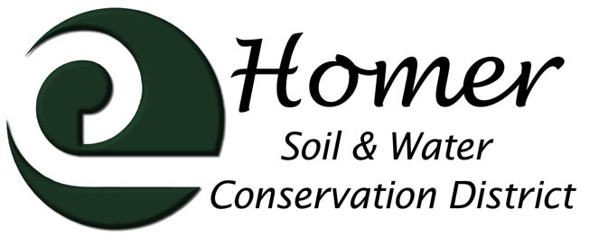
Meeting Agenda
4014 Lake St., Suite 201
Homer, AK 99603
907-235-8177 ext. 5
info@homerswcd.org

July 12th, 2017

5:30 dinner, meeting 6pm

USDA Service Center, 4014 Lake St Homer, AK
- Call to order 6:30
- Roll call : Tim Alzheimer, Gena Grobarek, Chris Rainwater, Karin Sonnen
- Approval of the Agenda: unanimous approval
- Approval of the Minutes Tim motioned, Gena seconded, passes
- Visitors
  - NRCS Report
NRCS Report - Homer Soil and Water Conservation District Meeting
Karin Sonnen 7/12/2017
EQIP Update-
NRCS Alaska received an additional $2,270,000. This funded 48 additional contracts, 7 were in Homer totaling $165,350 in additional funds.

For FY 17, Homer has received 37 contracts totaling $833,878.

Changes for FY 18 contracts:
- For High tunnel eligibility, the land has to be planted to a garden edible crop. No more cover crops to meet eligibility.
- Applicants must file for water rights if they are being funded for any water consumptive practice. They can wait until they are close to being funded before providing this documentation.
- Fall certifications where the lid of the high tunnel is left off, because they are going to leave it off for the winter, are no longer allowed. The high tunnel must be totally complete before NRCS will pay the reimbursement.

Homer Field Office currently has 56 applicants for 2018 – and counting.

Field employees are currently working on finishing any paperwork or planning on these additional files and getting signatures on contracts. Also completing certifications for existing practices and taking new applications, fielding questions, etc.

Since Ryan Left, Meg Mueller has given many of his contracts to be attended to and completed by Pam Voeller and Craig Sanders, both in Kenai.

Jared is attending training this week in Bozeman (Supervising for Excellence). Karin will be out of the office July 20- Aug 3, backpacking, attending biology training in Kenai, and completing field work on the Seward Peninsula. Jen is the calm and steady presence in the office, keeping people informed and payments flowing smoothly

  - Other guests - none
- Financial Report
Motion to approve by Gena , seconded Tim, passes
- Manager’s Report

- Trails
  - Caribou Lakes Trail: Planning upcoming trip out to photo document and GPS the problem areas. Recent trip out by state officials lead to questions about trail maintenance.
  - Watermelon Trail: SCA crew a total disaster. Looking into trail work that can be done this summer by more professional crew. Waiting to hear back from SCA as to how they are going to remediate their disaster.
  - School Yard Habitat Trails: Looking into hiring Conrad Field to develop interpretive signs this summer, otherwise on hold till school starts.
- Invasive Plant Program Invasive Pest Coordination
  - Chugach National Forest/RAC grant work: Matt is lining up new collaborations to accomplish the work Jamie was lined up to do, she failed to get certified to spray.
  - Cooperative Weed Management: Matt is on hold for further action on items outlined in our USF&W agreement until funding is restored. This includes all work in the villages across the Bay, and right-of-way weed control. He is in Bradley Lake right now working on that infestation because a) it is so utterly timely, b) HEA is footing much of the bill, c) the collaboration there is so complicated it would be devastating to let it drop now.
- Grants
  - Fish and Wildlife: All paperwork has been signed (again) for our new agreement with F&W, but we have not yet received an agreement…Waiting to hear.
  - Division of Ag: (grant for consumer study) Waiting to hear.
  - Rural Business Development Grant: (grant for a producer study) Waiting to hear.
  - BLM: Good news! We got $100,000 for AIM specific work in Nulatto Hills, $50,000 for soil survey work up there, and $20,000 for mining reclaim monitoring.
  - Ag in the Classroom: (Education on classroom hydroponic and year-round growing techniques) Grant has been awarded, waiting to hear details from Fairbanks SWCD.
  - NRCS: Matt has put together a proposal to work with the villages of Port Graham and Nanwalek and the DOT to create a plan for controlling the spread or introduction of invasives during the new airport/road creation and another proposal to develop recommendations for the Caribou Lake Trail. Waiting to hear.
  - ACWA Grant: (Anchor Rive streambank erosion project) Still waiting to hear.

Questions: what was the life of the RBEG grant for the rhodiola equipment? Did Al get a new one?
- New Business
  - Trail Sponsorship: in regards to requests from John Coila and Jeff/Shelley re: Caribou Lake area trails an boardwalks. Will HSWCD sponsor RTP grants for their projects? Board response: Trail users need to look into creating a user group. With a group of people behind a plan that is well defined, the Board would be better able to assess the capacity for the project to succeed.
  - Local Working Group: Not in August! Do it when there are plenty of folks who can attend. We are too late to get into plans for NRCS now unless we do an informal collaborative soon.
  - Annual Plan of Work: tabled till next meeting

Next Meeting August 9th, 2017, 5:30pm

