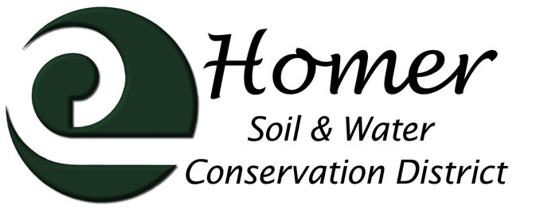
Meeting Agenda
4014 Lake St., Suite 201
Homer, AK 99603
907-235-8177 ext. 5
info@homerswcd.org

September 13th, 2017

5:30 PM

USDA Service Center, 4014 Lake St Homer, AK
- Call to order
- Roll call
- Approval of the Agenda
- Approval of the Minutes
- Visitors
  - NRCS Report
  - Other guests
- Financial Report
- Manager’s Report
  - Trails
  - Invasives
  - Soils
  - Local Food
  - Grants
  - November conferences and vacations
  - Rhodiola Equipment
- Old Business
  - Cooperator List!!!

- New Business
  - Comp Plan Ag section
  - DNR land offering
  - Other?

Next Meeting October 11th, 2017, 5pm???

