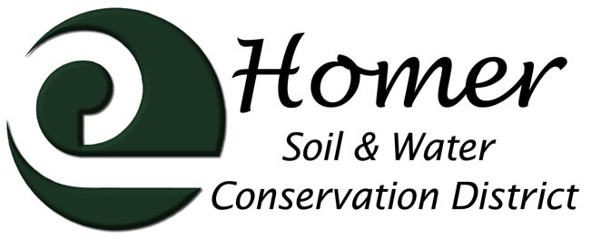
Meeting Agenda
4014 Lake St., Suite 201
Homer, AK 99603
907-235-8177 ext. 5
info@homerswcd.org

April 12th, 2017

5:00 PM

USDA Service Center, 4014 Lake St Homer, AK
- Call to order: 5:30pm
- Roll call: Catherine Knott, Genarita Grobarek, Chris Rainwater, Tim lzeimer, Devony Lehner. Otto Kilcher abesent
- Approval of the Agenda: moved by Gena seconded by Tim
- Approval of the Minutes : moved by Gena seconded by Tim
- Visitors
  - FSA Erin Sturdivant (by phone): Having elections for a canidate in the MatSu Borough, Non-insured program, Farm Loan program for annual operating expenses. Farm Storage Facilities program has new eligibilities. Livestock endemnity. Accessible on website (Alaska FSA page). Erin will be visiting Mon-Wed next week, can visit farms. Good for new producers. Gena asked if we could set up a class on bookkeeping for new farmers so they collect the right info for farm loans. Will send a link for workshop info for loan program. Also good for producers to keep good records for natural disaster relief programs. Will send link for FSA newsletter. Put FSA info in newsletter.
  - KPB Marcus Mueller- unable to attend
  - NRCS Report from Meg Mueller
Conservation Planning and Programs:
Approximately 32 applications moving to contracting Homer. Contract Reviews and Practice Reminder letters have gone out for existing contracts.
Working Lands for Wildlife and Mountains to Sea - 2017 will be an inventory and evaluation year (good!). USFWS, Alicia, and two Kenai Watershed Forum staff will take training with ADF&G assessors. No widespread outreach necessary - very targeted, efficient, and precise, and based on inventory findings. Will be cataloging fish passage around the Peninsula.
Conservation Client Gateway is available to entities and individuals. Participants can electronically view, sign and send documents and track payments. https://www.nrcs.usda.gov/wps/portal/nrcs/main/national/cgate/
State Technical Committee Meeting being scheduled – Statewide EQIP Priorities to be on agenda
Other:
The State Technical Committee will meet Thursday, May 11. The meeting will begin at 9 a.m. and adjourn by noon.

The NRCS State Technical Committee provides opinions on issues within a variety of NRCS conservation programs. The meetings are open to public participation. Draft agenda items for the May 2017 meeting include discussion on dune stabilization on Akun Island, soil health projects across Alaska, resource concerns with pond planning and design, Emergency Watershed Protection Projects, and the Environmental Quality Incentive Program.
Homer office –NRCS advertised for space. Anticipate a move – within 6 months? Unoccupied federal facility received highest priority, though the owner would have to do the build-out. Process for acquiring space is with admin team.
Staffing - New Assistant State Conservationist for Programs on board from North Dakota, Amanda Crowe. New Hub Leader in Wasilla with unofficial selection, Joanne (North Hub Leader) continues fill in. Ryan unofficially selected for Delta Junction GS-11 Soil Conservationist. Unofficially selected remain in hiring freeze gray area. State Resource Conservationist position to be filled, Scott Crockett acting. Two Soil Conservationists to be advertised for Homer. States anticipated to lose 10% of discretionary funding from 2016 levels.
Soil Health Training in 2017 – August 28th still on schedule
Meg Out of Office: 24-27 April in Hoonah, 8-11 May in Greensboro Hoonah was the recipient of a regional allocation through RCCP (EQIP)
  - AACD update: the present Executive Director resigned and replaced without full board approvable. New meeting scheduled for April 25th. Questions abound about what the new AACD will look like
- Financial Report Gena requested to add reconcile report in the future Mothion to accept Cathy, seconded by Gena
- Manager’s Report
  - CIRI/Watermelon Trail: Is Harry Crawford’s easement with the borough? Could we charge Snomads for permitting? Tim pointed out that this would open up to massive snowmachining. Do we have an MOU with Snomads on Caribou Lake Trail?
  - School Yard Habitat
  - Soil Health Course in Palmer in August
  - Invasive Plant Program
  - Kenai Peninsula Fish Habitat Partnership Science Symposium
  - Kachemak Bay Watershed Collaboration Working Group
  - Growing Success class
- Old Business
  - Cooperator List
  - Employee Pay Rates
  - Rhodiola Equipment - Tabled
  - Water Rights - Tabled
- New Business
  - Future Scenarios: Possible Funding
    - FMPP turned in
    - RAC grant signed
    - Specialty Crop Block Grant requested us to turn in application
    - Business Development Grant due at the end of April
End at9pm
Next Meeting May 10th, 2017

